Random Sequences
(Also known as random process with discrete time intervals)

A stochastic or random sequence (RS) is represented by an infinite dimensional random matrix 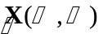whose entries are time indexed random variables defined on sample space 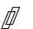and at times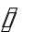which are usually the set of integers 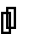. A row of , 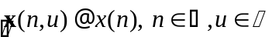, is a deterministic sequence of outcomes defined by the realization of a random experiment that evolves over time. A row depends only on and hence is known as a sample function or a realization of the random sequence, hence the notation 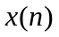. A column of is simply the random variable 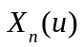 linked to an experiment performed at time where ranges over all possible outcomes in . The collection of all rows and columns therefore defines the RS over the set of permissible outcomes and times. Typically, we denote the random sequence by 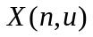, or by analogy with the suppression of the sample space in random variable 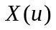, simply as 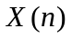. A realization of the sequence will be denoted by lower case letters following the convention ().

A further distinction involves classifying the sequence as discrete if the numerical values take on a finite set, and continuous if the set is infinite.

In what follows we assume the RSs are either square integrable and hence convergent, i.e.

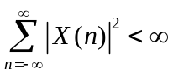

or have finite power and hence are convergent.

Example 10.1

Suppose a dice is thrown 1000 times…..there are 6^1000 possible outcome sequences (1,4,3,2,2,6…..3). Each outcome sequence is a sample function. Each roll is a random variable. In the limit as the number of rolls becomes infinite we have a random sequence.

Statistical Characterization

A RS is specified up to order 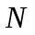by the outcomes ofrandom variables that occur at times, and is described by the corresponding ^{th} order CDF

where the boldfaced subscript is used to indicate a vector function. The times in are explicitly indicated as an argument to emphasize the fact that the CDF is dependent on the N times at which the RVs are realized. This function changes according to the sequence of times and outcomes and also according to the number of them. Typically, the time indices are consecutive and we may index the times by consecutive integers. An infinite number of different distribution functions ranging over all time intervals are required to fully describe the sequence in a statistical manner.

Alternately, we may use the Nth order pdf 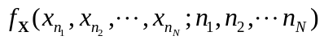 defined by

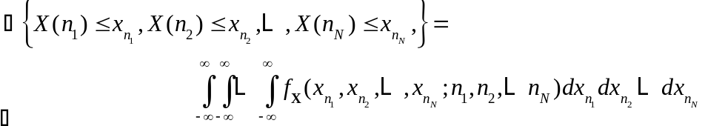

To simplify notation we define the following compact representations of and : Letting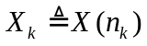,

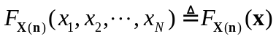

is the N^{th} order CDF, and

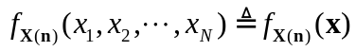

is the N^{th} order pdf for the random sequence/vector 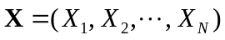at times specified by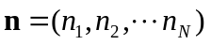.

Because it is impossible to know all N^{th} order descriptions over all times RSs are generally described by their first and second order statistics. The time varying ensemble mean function is

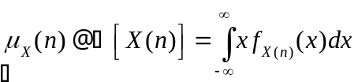

which is the average value of the random variable 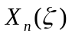at timebased on the single time pdf 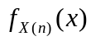. The second order ensemble average is the autocorrelation function

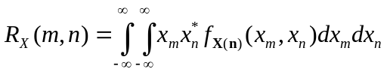

which measures the linear relationship between random variables 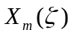and occurring at times and . The autocorrelation function may be expressed more simply as

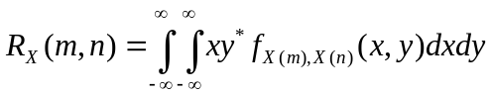

where 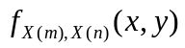is the two dimensional pdf of the dummy random variables X and Y occurring at the indicated times. Because the autocorrelation typically decays monotonically in time, the farther off in time one goes, the smaller the dependence between successive times. Therefore, the autocorrelation function is really a first order measure of the behavior of the sequence over time.

The auto-covariance function 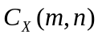 may also be defined as

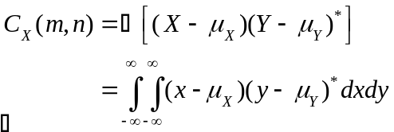

with

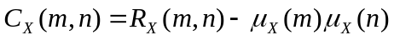

Although most RS are assumed or processed to have zero mean so that 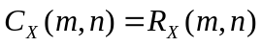.

Even these descriptions are too complicated and for better or worse we must make still more simplifying assumptions and approximations. The following descriptions, however, are fairly accurate for a large class of RS.

Gaussian Random Sequences

A RS is Gaussian if its N^{th} order pdf is Gaussian. Gaussian sequences have the advantage of requiring only a mean and variance to achieve a complete statistical description.

iid Random Sequence

For iid random sequences defined by the RVs 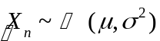, the N^{th} order joint pdf is the product of N identical pdfs

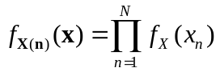
so that the mean is

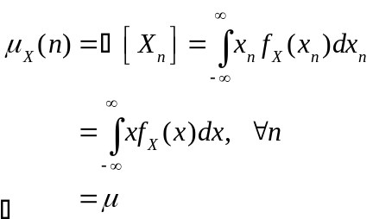

i.e., constant. The autocorrelation function is

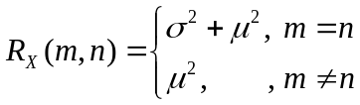

where independence was used.

Stationarity

So called strict sense stationarity implies that the N^{th} order distributionals are shift invariant. Stationarity is required when estimating statistical quantities such as mean and variance based on an observed sample. If the sample statistics are changing with time then combining unlike variables under the assumption they are similar leads to inaccurate results. If a sequence of random variables is non-stationary, the data can be broken down into smaller time windows or attempt to detrend the data by subtracting the time varying trend.

Wide Sense Stationarity (WSS)

If we require stationarity up to order two only , i.e. 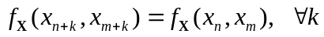, then

- Mean function is a constant for all so that

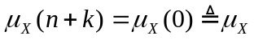

- Autocorrelation is a function of relative time, not absolute time, i.e. it is a function of time difference between occurrences of two RVs. We have for all , 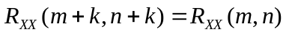 or for k=-n,
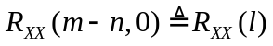

Therefore, the autocorrelation function dependent only on shifts from the origin equal to the time separation.

Properties of Correlation Function for WSS Random Sequences

1) Conjugate symmetry. 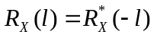

Proof:
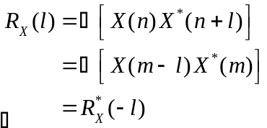
2) Max value at zero shift. 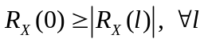

Furthermore, the energy (or power when divided by a 1 ohm resistor) in the sequence is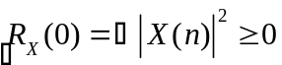.

3) Positive Semi-definiteness.

Random Sequences and Linear System

Let and 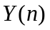be the input and output random sequences, respectively, of a linear system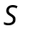that is described by a linear constant coefficient difference equation

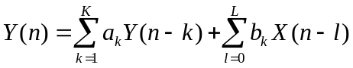

Linear systems are described by their possibly time-varying impulse response function (deterministic) 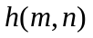so that the input output relationship is the time dependent convolution

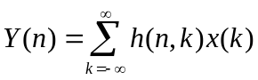
The output mean is then

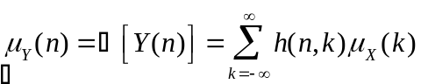

and the output correlation function is

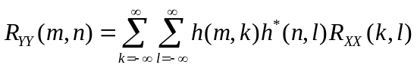

Processing by LTI Systems

For LTI systems with WSS inputs the input output relationships are also WSS and LTI, and are easily shown to be

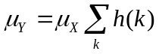
and

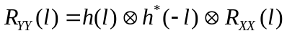

Invoking the results of the following section, the frequency domain relationships follow easily as well:

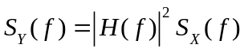

show example 6.2.1 filter is stationary

Power Spectral Density

Since a signal with nonzero average power is not square integrable (i.e. finite energy), the Fourier transforms do not exist in this case, though a Fourier transform may be coaxed into existence by multiplying by a factor that tends to zero and then applying limiting arguments. A RS has infinite extent, and hence infinite energy, but has finite power 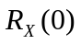.

The energy of a deterministic signal x(t) whose Fourier transform X(f) exists, is by Parseval’s Theorem

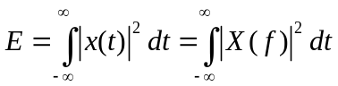

so that we may consider 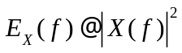as the energy density of the signal. For a signal with finite power but infinite energy we define the power spectral density (PSD) in a similar manner to the expression for power in

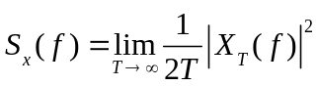

where 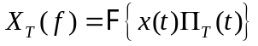 and 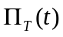is the length 2T symmetric rectangular window function

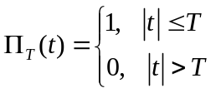

For a random sequencewith finite power average we define its PSD as

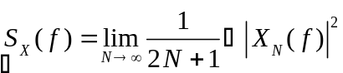

where 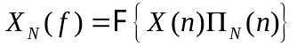. Expanding

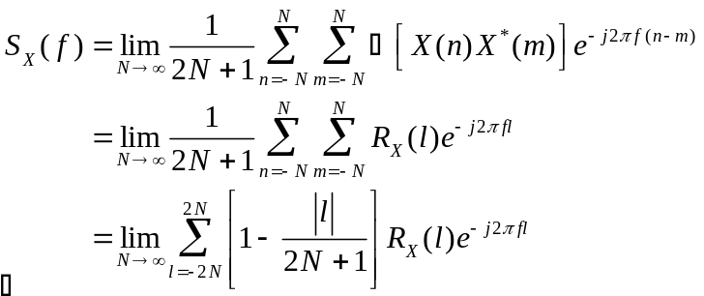

where 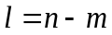 and the last line follows from the identity

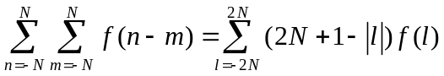

where 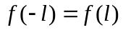(i.e. autocorrelation function is assumed real) which is proved in Appendix A. Therefore, the PSD of a random sequence is, if the autocorrelation function decays at the rate of a polynomial of degree >1, in the limit

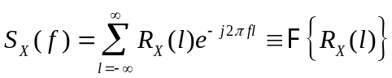

The expression containing the energy density at frequency f, which is a random variable, converges in the mean to as T goes to infinity. However, the variance of the random variable energy density does not converge to zero for all f. Therefore, there may be some f for which the limit does not hold, though on average it does. More to be said.

Also, () suggests the approximation 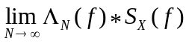which shows that the long we observe X the better the estimate of its PSD. This is spectral estimation.

Example 10.2

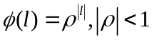

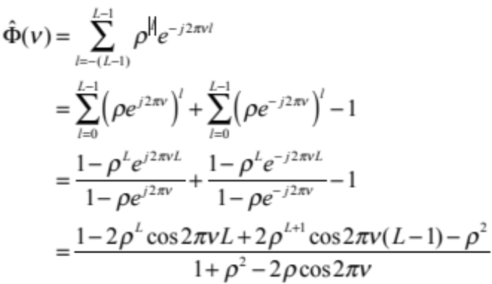

then taking the limit

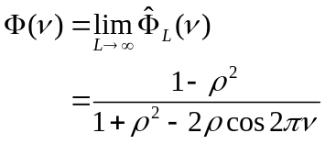

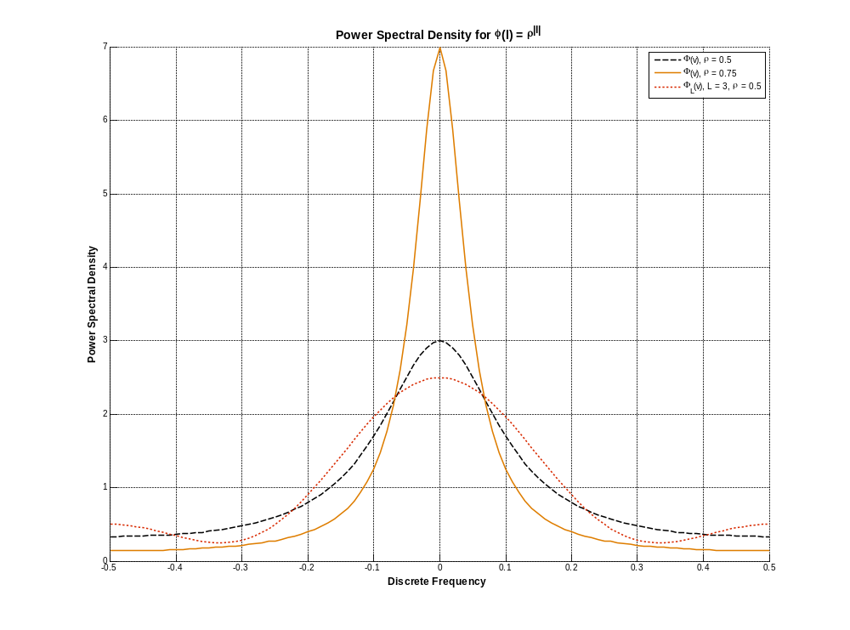
The 3dB - bandwidth is

Simulating Random Sequences

Suppose we seek a filter h(n) that when driven by a white noise process with variance 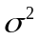 will exhibit an output sequence characterized by pre-specified desired parameters. From , the transfer function is

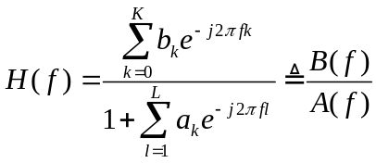
so that the output PSD is

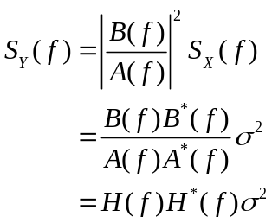

where 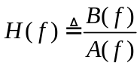. Therefore, based on the coefficients of the difference equation and the desired form of the output PSD the filter h(n) may be designed.

Autoregressive Processes

